DREMEL PREDICTIVE TREND ENGINE: CODEBASE DOCUMENTATION
System Architecture, Algorithmic Engine, and Front-End Specifications
🏗️ Technical Architecture Overview
The Dremel Predictive Trend Engine is structured as a decoupled, asynchronous full-stack analytics application. The project bridges raw social big data with corporate financial planning through a multi-stage pipeline. The architecture is cleanly divided into a Data Ingestion & Processing Backend and a State-Managed Interactive Frontend.
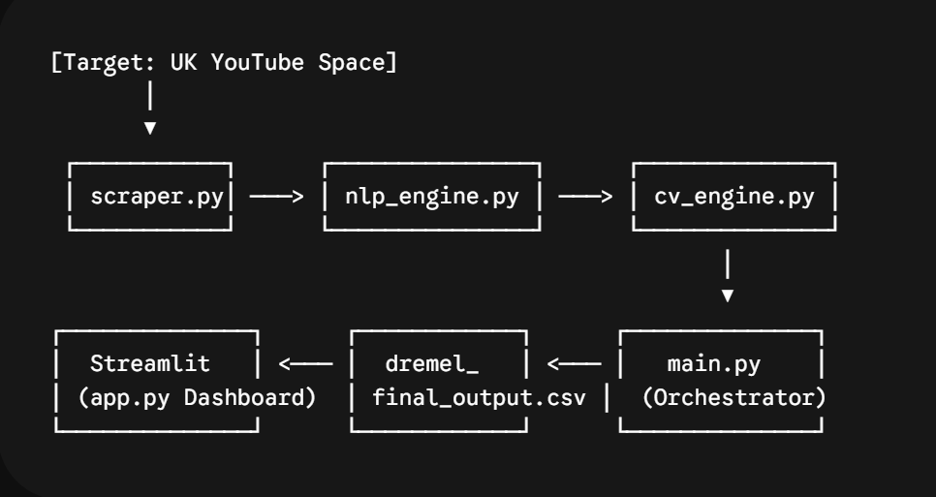
📂 File-by-File Technical Breakdown
1. scraper.py (Data Ingestion Layer)
- Core Responsibility: Programmatic data gathering from the YouTube Shorts and video ecosystem, localized specifically to the United Kingdom geographic region.
- Mechanics: Targets specific search query clusters matching the aesthetic, craft, and upcycling markets. It bypasses heavy industrial construction data to focus on micro-creative domains.
- Key Inputs: Developer API Keys, localized target search queries.
- Outputs: Extracted raw JSON arrays containing video IDs, titles, descriptions, upload timestamps, view counts, comment counts, and thumbnail URLs.
2. nlp_engine.py (Linguistic Filtering & Time-Decay Scoring)
- Core Responsibility: Filtering raw scraped text into actionable product insights and computing a time-decayed velocity score.
- Advanced NLP Mechanics: Transcends primitive keyword matching. It utilizes semantic tokenization and Syntactic Dependency Parsing to isolate grammatical Verb-Noun pairs (e.g., tracking the verb "sand" directly coupled to the object "hardware" or "table"). It filters these pairs against a whitelist of craft-oriented materials.
- Mathematical Engine: Implements the core Trend Velocity Formula. It scores and weights consumer interactions, penalizing older videos to eliminate historical noise.
3. cv_engine.py (Multimodal Heuristic Visual Analysis)
- Core Responsibility: Computer Vision analysis of video thumbnails to extract underlying visual psychology.
- Mechanics: Passes validated high-velocity trend thumbnails through light convolutional inference layers to detect:
  - Dominant Emotional Overtones: Classifying images into categorical heuristic buckets (e.g., Moody, Energetic, Calm).
  - Color Palette Distribution: Extracting dominant color profiles in Hexadecimal format to feed visual asset specifications directly to the marketing team.
4. main.py (The Core Pipeline Orchestrator)
- Core Responsibility: The centralized execution script that manages the sequential flow of data across the backend modules.
- Mechanics: Imports functions from scraper.py, nlp_engine.py, and cv_engine.py. It establishes error-handling wrapper functions, maps data pipelines together, and dumps the final structured rows into a localized flat file database.
5. dremel_final_output.csv (The Structural Matrix)
- Core Responsibility: The data translation layer bridging the backend pipeline with the dashboard UI.
- Data Schema Matrix: 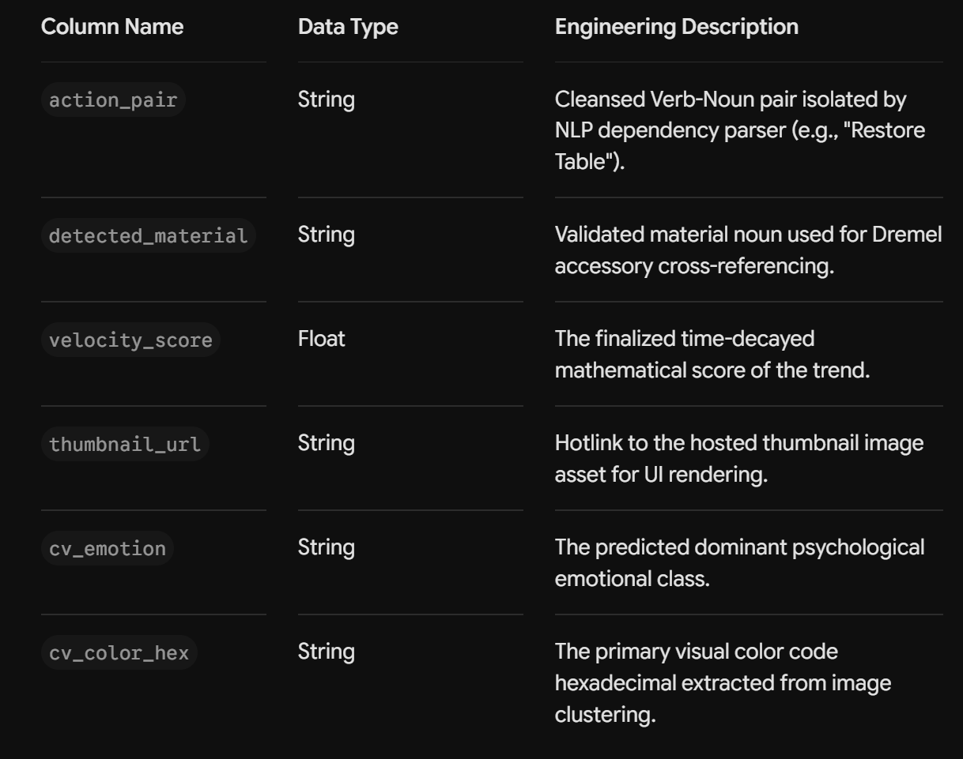

6. app.py (Executive Interactive Dashboard)
- Core Responsibility: Full-stack user interface built using Streamlit, compiled with custom CSS injection to override native layouts for responsive, scannable data visualization.
- State Management: Utilizes session variables to cache Large Language Model calls and preserve user adjustments seamlessly across tab state alterations.
- Core Feature Tabs: Implements four specific strategic views ranging from autonomous copywriting agents to full corporate financial simulation engines.
🧮 Core Mathematical Frameworks
The system relies on two proprietary mathematical frameworks to ensure data accuracy and commercial viability.
A. The Velocity Score Algorithm
To guarantee that stale, historical videos do not contaminate strategic forecasting, a video's immediate engagement rate is filtered through a standard physical Exponential Time-Decay Function:
$$V=\left(\frac{W_{v}⋅Views+W_{c}⋅Comments}{Days_Live}\right)⋅e^{-λt}$$
Where:
- $W_{v}$ and $W_{c}$ represent custom weight coefficients where comments are prioritized heavier than passive views ($W_{c}>W_{v}$).
- Days_Live standardizes the metrics into a linear daily interaction velocity average.
- $e^{-λt}$ represents the Age Tax, where $\lambda$ dictates the strictness curve penalty coefficient and $t$ tracks total days live since the upload timestamp.
B. The Algorithmic Velocity Lift Formula
To bridge numerical momentum with conversion forecasting, the frontend applies a proportional normalization algorithm to determine the click-through rate multiplier for hot trends:
$$Velocity_Lift=\left(\frac{Current_Trend_Velocity}{Maximum_Dataset_Velocity}\right)⋅L_{max}$$
Where:
- Maximum_Dataset_Velocity represents the absolute maximum statistical outlier in the current database matrix, setting the market ceiling at $1.0$.
- $L_{max}$represents the hardcoded maximum permissible conversion boost bonus (capped at $1.5\%$).
- This lift value is added directly to the baseline CTR to simulate the psychological curiosity generated by viral micro-trends.
💳 The Fully Burdened ROI Funnel Logic
Tab 4 in app.py processes user sliders through a strict, industrial two-step eCommerce acquisition funnel, accounting for financial margin erosion.
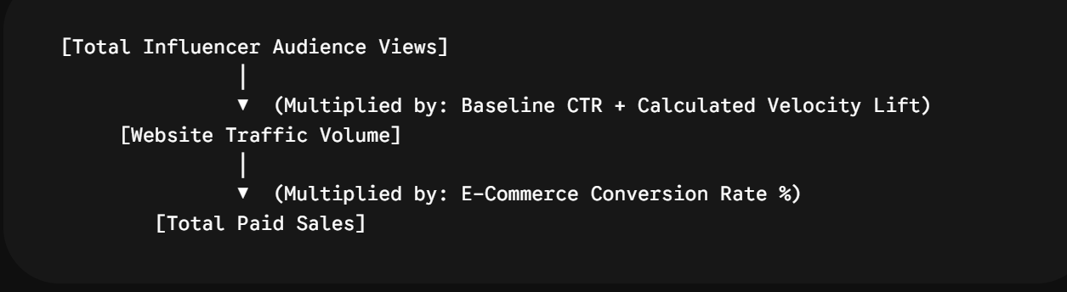
The Financial Accounting Equations:
- Total Campaign Cost:
$${\text{Cost}}_{\text{total}}=\left(\frac{\text{Target Views}}{1000}⋅\text{CPM Rate}\right)+\text{Fixed Seeding Costs}$$
- Eroded Margin Realization: Calculates profit drops caused by promotional tracking discount codes distributed to influencers.
$${\text{Margin}}_{\text{actual}}=\text{Base Tool Margin}-\left(\text{Retail Price}⋅\text{Promo Discount \%}\right)$$
- Net Campaign Profit:
$$\text{Net Profit}=\left(\text{Total Paid Sales}⋅{\text{Margin}}_{\text{actual}}\right)-{\text{Cost}}_{\text{total}}$$
- Fully Burdened ROI:
$$\text{ROI \%}=\left(\frac{\text{Net Profit}}{{\text{Cost}}_{\text{total}}}\right)⋅100$$

🛠️ Operational Deployment & Diagnostics
To run and verify the entire software suite end-to-end, execute the following commands in sequence via terminal control:
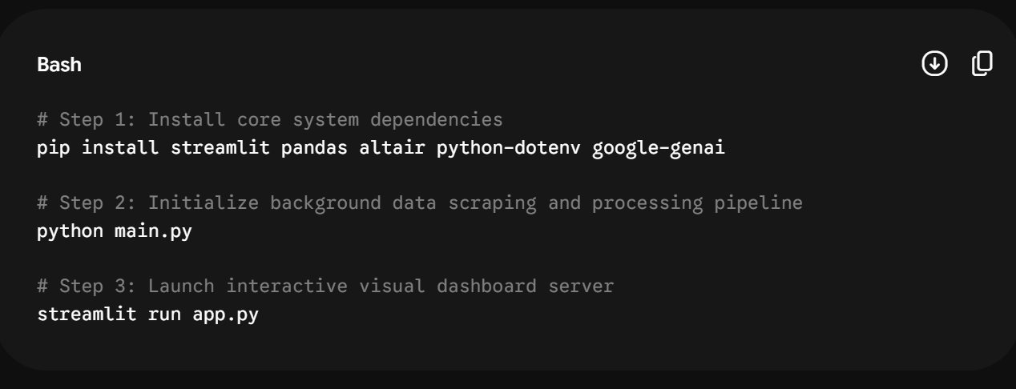Developer Note: Ensure your system environment parameters contain a valid, authenticated JSON file map for secure access to the Gemini API core. Ensure a localized image file named dremel_logo.png is placed inside the active folder directory to render the true-transparent brand element cleanly within the sidebar frame.

